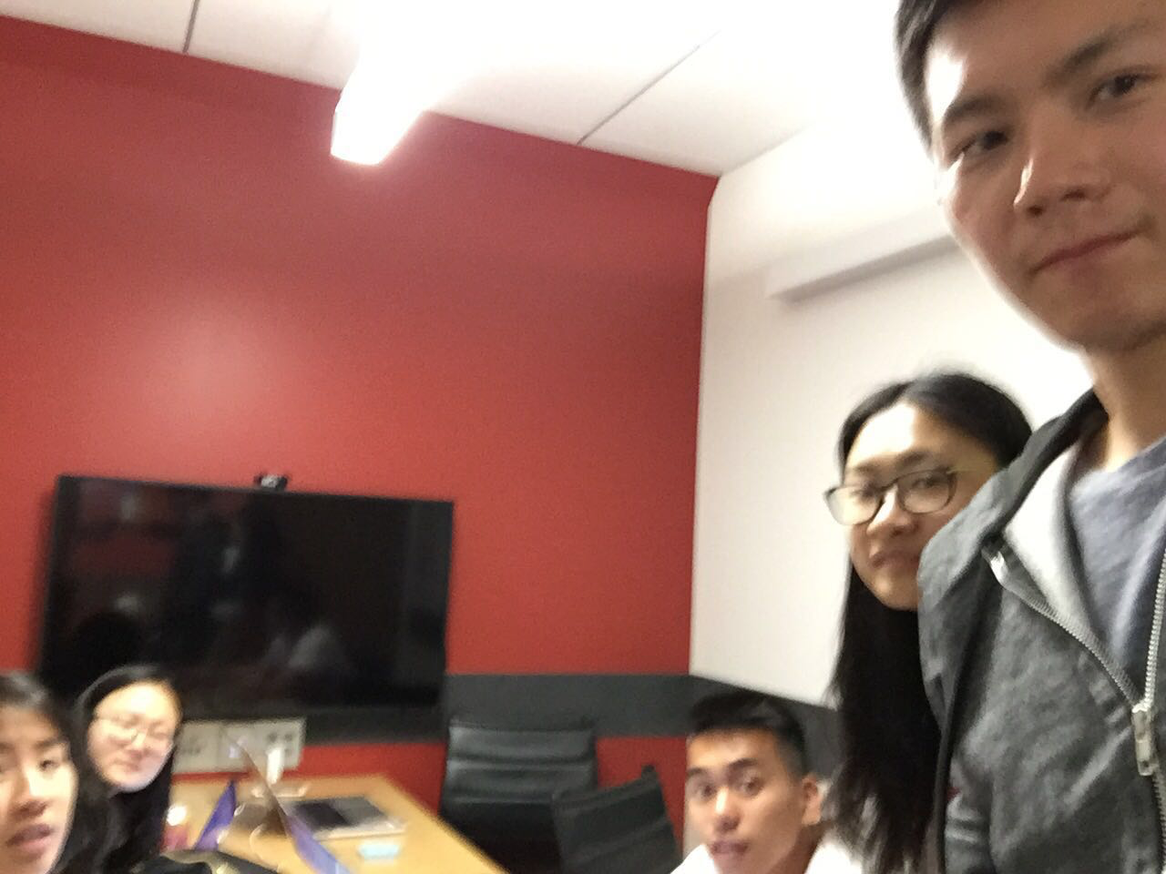

Allocated meeting time: April 23rd, 8:00pm-9:00pm

Actual meeting time: April 23rd, 8:00pm-9:00pm

Product owner: Professor Halfond, TAs, CPs

Scrum master: Gong Chen

Team members: Lingyi Li, Joann Lin, Peixuan Liu, Ryan To, Tuling Zhao

Scrum summary:

We were fixing bugs of our implementation of the new functionalities from our new sprint backlog. We also started to write the process report.

1. What have you accomplished since the last meeting?
2. Are there any obstacles in the way of meeting your goal?
3. What will you accomplish before the next meeting?

Gong Chen:

1. Fixing the size of exported collage.
2. None.
3. Fixing the black&white filter.

Lingyi Li:

1. I was creating the burndown charts.
2. None.
3. I will finish the burndown charts and write other sections in the document

Joann Lin:

1. Worked on testing the export and saved features to make sure they are bug free.
2. None
3. Will modify styling to make website responsive

Peixuan Liu:

1. Added test cases to CollageServletTest and SignUpServletTest
2. None
3. Add test cases to SaveCollageServletTest

Ryan To:

1. I added more test cases for saving the history, as well as deleting the history
2. none
3. I will write test cases for testing https and downloads functionality

Tuling Zhao:

1. Fixed bugs
2. None
3. Will work on documentation

Absence Reason: Went to class from 7 to 9:50 pm